Title of the presentation (14 pt, Times New Roman, bold, centered)
Lecturer Underlinedª, Coauthors^{b}
ªName and corresponding address of workplace/department 10 pt, italics, centered
^{b}Name and corresponding address of workplace/department 10 pt, italics, centered
It should be a short summary of your presentation that states the problem, the methods used, and the major results and conclusions. The abstract must be up to 1 page long (font style Times New Roman, font size 12 pt, single line spacing).
Figures can be included as follow (centered):
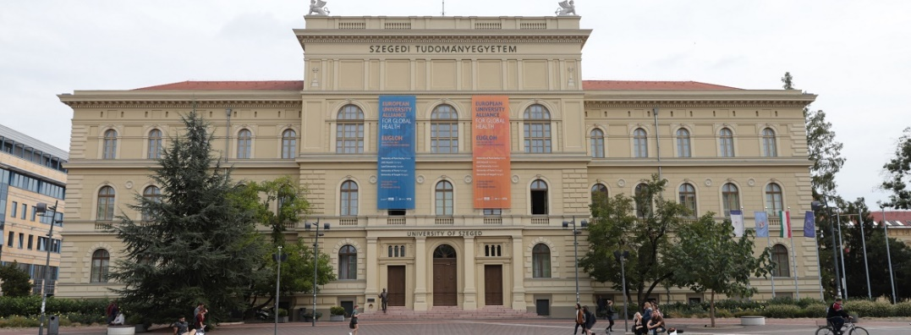
Citations should be given at the end of the abstract. Number of them in square brackets [1,2], in the following format:

[1] X. Surname, Y. Z. Surname: Name of the journal, year (volume), first page-last page.
[2] H. T. Smith et al.: Nature, 1985 (318), 162-163.

Acknowledgment, 10 pt, Times New Roman, bold.

